
Component Model
Parse the Laser Sensor Data
to Point Cloud
Robotic Cognition System for Wheelchair
Unicamp

Table of Contents
1 Purpose of this Document 3
2 Component Design 4
2.1 Purpose 4
2.2 System Diagram 4
2.3 Component Input 4
2.4 Component Output 4
2.5 Component Processing 4
3 Component Execution 6
4 References 8

Document Information
Project Name: | Robotic Cognition System for Wheelchair
Prepared By: | Tarcísio Franco de Carvalho | Document Version No: | 1.0
Title: | Component Model – Parse the Laser Sensor Data  to Point Cloud | Document Version Date: | 05/Aug/2020
Reviewed By: |  | Review Date:
Distribution List
From | Date | Email

Acronyms
Acronym | Description
ROS | Robot Operational System

Document Version History
Version  Number | Version  Date | Revised By | Description
1.0 | 05/Aug/2020 | Tarcisio | Initial Version

Purpose of this Document
Define how the related component works and its relation in the main system.

Component Design

Purpose
This component is responsible to transform the laser sensor data to point cloud data captured from a diode laser or a range finder laser. The point cloud produced by this component will be one of the inputs to classify the ground passage condition for a wheelchair robot.

System Diagram
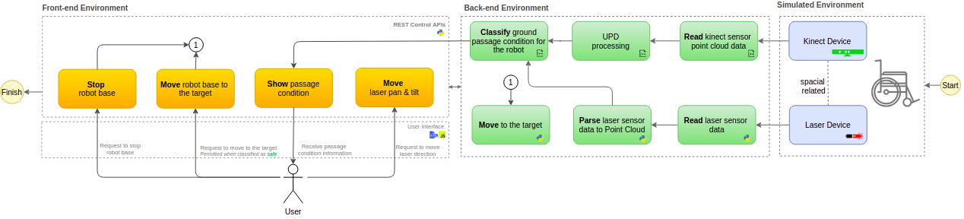

Component Input
This component reads the ROS node “/laser/pointer” that publishes the laser data from its environment.

Component Output
This component publishes the parsed laser data as point cloud data format on the ROS node “/laser/point_cloud” in a defined cycle.

Component Processing
This component reads the laser data, parse and publisher its as point cloud data on a ROS node. The diagram below shows this relationship:
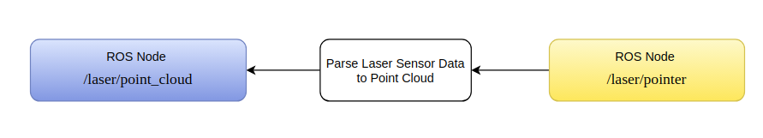

Below the main process flow for this component that occurs in cycles:

- Read laser data from /laser/pointer ROS node
- Parse the laser data to point cloud data
- Publish the laser point cloud data to /laser/point_cloud ROS node

Component Execution

To execute this component is necessary the Gazebo simulation environment, ROS main process running and the Rviz tool to show processed data. Bellow the steps to run this component:

- Start Gazebo environment simulation
On the project root folder, run the script ./sim_model/scripts/launch.sh it will process the simple_blocks.world and sim_model.urdf.xacro files

Result
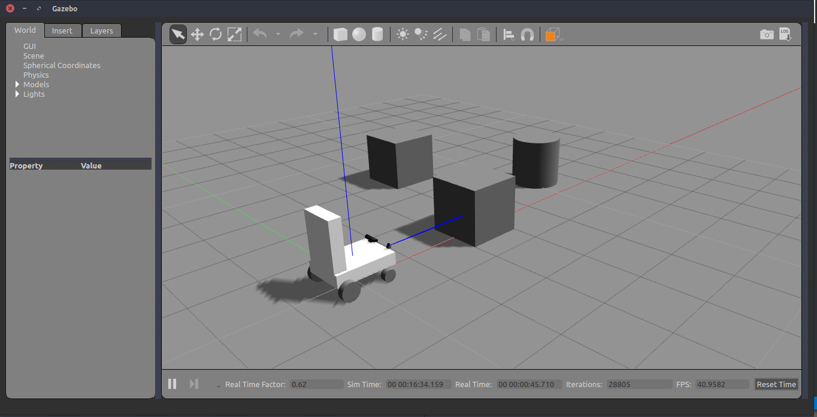

- Start the Parse Laser Sensor Data to Point Cloud component

On the project root folder, run the script .python src/laser_publisher.py it will start a node to published point cloud laser data

Result
In Rviz the point cloud related to the laser is showed.

Rviz | Gazebo
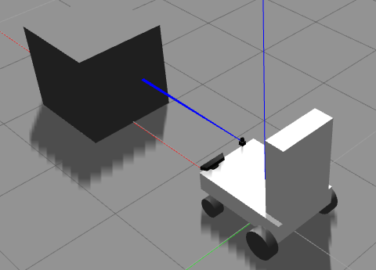
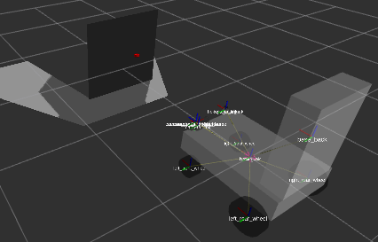

References

- Point Cloud
  - Accurate laser scanner to camera calibration with application to range sensor evaluation: https://link.springer.com/article/10.1186/s41074-017-0032-5
  - Convert Laser Scan to PointCloud: https://www.youtube.com/watch?v=GvilxcePD64
- ROS
  - Control: http://wiki.ros.org/ros_control
  - ROS and Gazebo Tutorial: http://wiki.ros.org/action/fullsearch/urdf/Tutorials/Using%20a%20URDF%20in%20Gazebo?action=fullsearch&context=180&value=linkto%3A%22urdf%2FTutorials%2FUsing+a+URDF+in+Gazebo%22

